

PRODUCT DATASHEET

Product Model: OPN

Product Code:
C4-B-10.5-NTAG216-v2
&
C5-B-10.5-NTAG216-v2

Updated: 22/01/2018

Approved by: John McLear

PUBLIC DOCUMENT

C4 PHYSICAL CHARACTERISTICS

Ring Dimensions
Diameter = Varies according to ring size
Height = constant 6.3mm +/- 0.2mm

Technical drawing
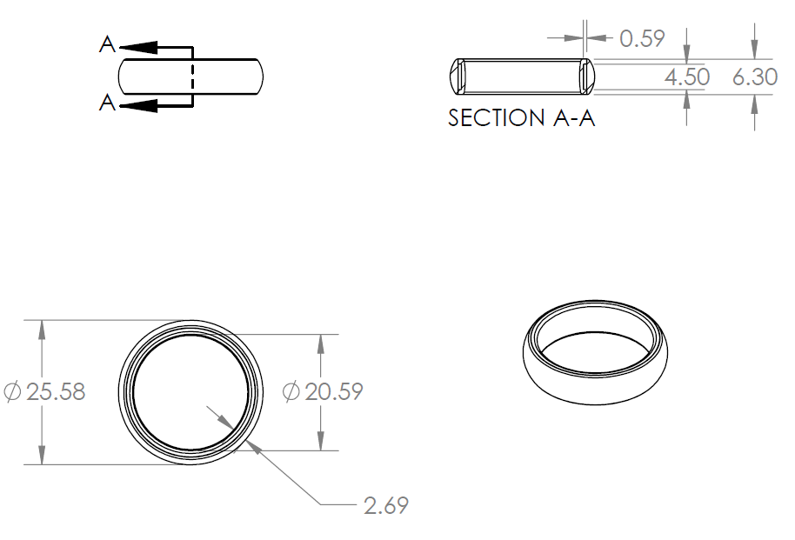

Available Sizes (United States Sizes)
9, 9.5, 10, 10.5, 11, 11.5, 12, 12.5, 13, 14, 15, 16 – For more information on sizes please refer to Ring Dimensions spreadsheet or http://nfcring.com/sizes
Note smaller ring sizes (4.5, 5, 6, 6.5, 7, 7.5, 8, 8.5) are not available in model C4 due to size of FPCB antenna. These smaller sizes are available as model C5

C5 PHYSICAL CHARACTERISTICS

Ring Dimensions
Diameter = Varies according to ring size
Height = constant 6.8mm +/- 0.2mm

Technical drawing
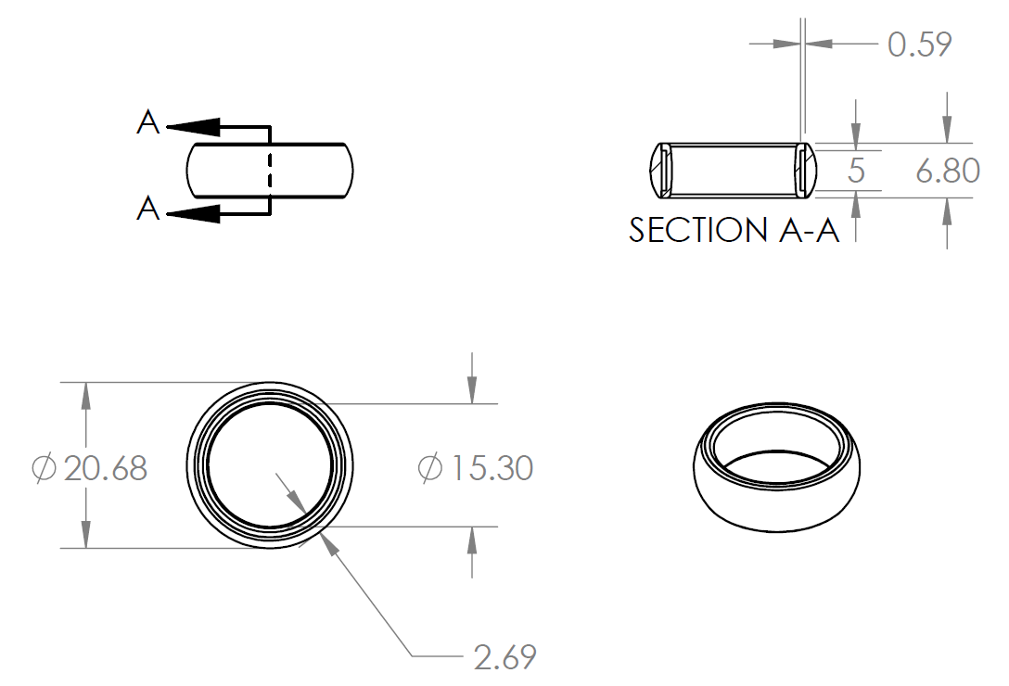

Available Sizes (United States Sizes)
4.5, 5, 6, 6.5, 7, 7.5, 8, 8.5 – For more information on sizes please refer to Ring Dimensions spreadsheet or http://nfcring.com/sizes
Note larger ring sizes (9, 9.5, 10, 10.5, 11, 11.5, 12, 12.5, 13, 14, 15, 16) are not available in model C5 due to size of FPCB antenna. These larger sizes are available as model C4.

Fit style
Comfort Fit: Soft Radius

Materials
Ring Blank: Hypoallergenic Hardened Advanced Ceramic (95% zirconium oxide + 5% yttrium oxide)
Glue: Two part ceramic epoxy glue
Inlay Material: FPCB PET

Colors
Blank: Black / White

Engraving
NFC Ring on inside
Product Code on inside

Antenna
C4 = 4.5mm tall loop coil FPCB (Flexible Printed Circuit Board)
C5 = 5mm tall loop coil FPCB (Flexible Printed Circuit Board)
Tin plated copper
Inlay max thickness 0.55mm

IC CHARACTERISTICS

Number of Ics(Integrated Components): 1
IC Manufacturer: NXP
IC Model: NTAG216
Full specifications: TBD
Operating Frequency: 13.5MHz → 15MHz
ISO/IEC: TBD
User writable space: TBD
Data retention: TBD
Write endurance: TBD
IC Type: Sawn Wafer
IC Mount Type: Wire bonded w/ glue

OPERATING LIMITATIONS

Forces
Can withstand drops onto most surfaces from 2M. Drops onto Ceramic and harder surfaces should be avoided.

Temperatures
Overall recommended temperature maximum exposures:
Min: -20c
Max: 100c
IC Limitation:
Min: -40c
Max: 100c

Epoxy Limitation:
Min: -20c
Max: 110c

Water resistance
IP66
Protected from Total dust ingress
Protected from high pressure washer jets from any direction

PATENTS AND LEGAL

Patents:

US 2015/0042450-A1: Covers:
Inserting NFC inlays in a Ring Embodiment (Both metallic and ceramic)
Using Hand Gestures to perform different tasks with a Ring including unlocking a phone and sharing contact information
Interacting between a Ring and an access control system
Current Licensees:
Visa Collab Inc
Mastercard Inc
DangerousThings Inc

US 2015/0042450-A1: Covers:
Inserting a transponder in a Ring
Communication between a Ring and third party device
Communication between a Ring and another Ring.

Trademarks:

“NFC Ring” is a registered Trademark of McLear Ltd

BEHAVIORAL CHARACTERISTICS

Operating Range

VivoPay Terminal: 20mm → 40mm
Keyduino Nano: 5mm
Elechouse PN532: 20mm
Nexus 5: 5mm
ACR122U: 25mm

Skin Interactions

The Ceramic and Epoxy used are both hypoallergenic materials and as such will cause no irritation to peoples skin under normal usage conditions.

Surface smoothness

The Ceramic embodiment is polished to a smooth finish. The largest pit on this finish is 100 microns.

